Sinh viên : Vũ Văn Trọng - 20184206

**ASSIGNMENT 1**

.data

A: .word -2, 6, -1, 3, -2

.text

main:

la $a0,A #load address of A

li $a1,5 #load immidiate 5 and store to $a1

j mspfx #jump to mspfx

nop #wait

continue:

lock: j lock

nop

end_of_main:

#-----------------------------------------------------------------

#Procedure mspfx

# @brief find the maximum-sum prefix in a list of integers

# @param[in] a0 the base address of this list(A) need to be processed.

# @param[in] a1 the number of elements in list(A)

# @param[out] v0 the length of sub-array of A in which max sum reachs.

# @param[out] v1 the max sum of a certain sub-array

#-----------------------------------------------------------------

#Procedure mspfx

#function: find the maximum-sum prefix in a list of integers

#the base address of this list(A) in $a0 and the number of

#elements is stored in a1

mspfx:

addi $v0,$zero,0 #initialize length in $v0 to 0

addi $v1,$zero,0 #initialize max sum in $v1to 0

addi $t0,$zero,0 #initialize index i in $t0 to 0

addi $t1,$zero,0 #initialize running sum in $t1 to 0

loop:

add $t2,$t0,$t0 #put 2i in $t2

add $t2,$t2,$t2 #put 4i in $t2

add $t3,$t2,$a0 #put 4i+A (address of A[i]) in $t3

lw $t4,0($t3) #load A[i] from mem(t3) into $t4

add $t1,$t1,$t4 #add A[i] to running sum in $t1

slt $t5,$v1,$t1 #set $t5 to 1 if max sum < new sum

bne $t5,$zero,mdfy #if max sum is less, modify results

j test #done?

mdfy:

addi $v0,$t0,1 #new max-sum prefix has length i+1

addi $v1,$t1,0 #new max sum is the running sum

test:

addi $t0,$t0,1 #advance the index i

slt $t5,$t0,$a1 #set $t5 to 1 if i<n

bne $t5,$zero,loop #repeat if i<n

done: j continue

mspfx_end:

* **Bảng Data Segment**

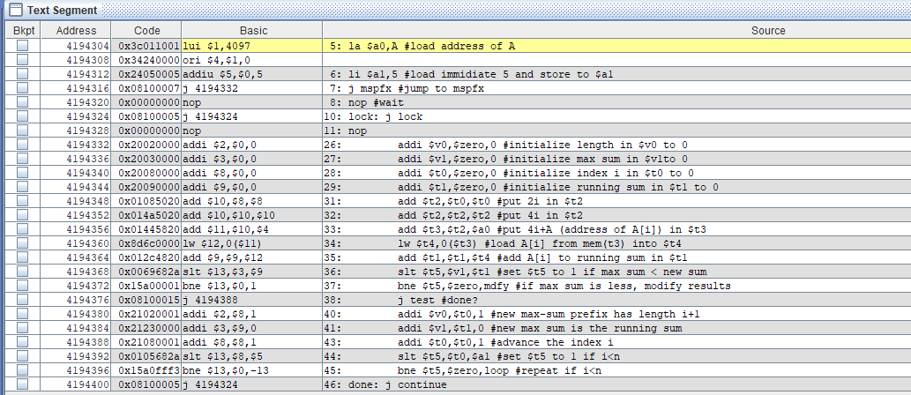

* **Bảng giá trị của các thanh ghi**

